First Time Homebuyer Credit for 2008 Purchases
- Maximum credit $7,500
- Repayment over 15 years - starting in the tax year 2010 return
- Purchases must have been completed between 4/9/2008 and 12/31/2008

First Time Homebuyer Credit for 2009 and 2010 Purchases
- Credits that were claimed on 2009 and 2010 tax returns do not have to be repaid unless certain repayment triggers are met. This is OUT OF SCOPE.

Repayments of Credit for 2008 purchases (Sources: Pub 17 or Form Instructions for Form 5405)
- Repayments for 2008 purchases are normally repaid in 15 equal annual installments beginning in 2010.
- The taxpayer may or may not receive a letter from the IRS for TY 2016. If the taxpayer received the First Time Homebuyer Credit in Year 2008, you can use the First Time Homebuyer Credit Account Look up tool to determine repay amounts and account balance. There is a link to the First-Time Homebuyer Credit Account Look up Tool on the Preparer’s page of Tax Prep4Free under the Internal Revenue Service below IRS Links.
- If the taxpayer bought the home in 2008 and owned and used it as their main home for all of 2016, the return is in scope.
- If the taxpayer dies, repayment of the credit is not required.
- If the taxpayer filed a joint return in 2008 and one of them died, the surviving spouse must pay back his or hers half of the credit. The remaining half (the half belonging to the deceased spouse) does not have to be repaid.
- If the taxpayer made a payment in TY2015 that was greater than the minimum, the minimum payment for TY2016 is still 1/15th of the original credit amount or the total remaining due. The loan will be paid off sooner than 15 years.
- Any other situations requiring use of form 5405 are OUT OF SCOPE.

Note: if you are making an installment payment of the credit you claimed for a home you purchased in 2008 and you owned it and used it as your main home during all of 2016 (the only in-scope situation for the form 5405), TaxSlayer does not print nor submit form 5405. The amount of the repayment is only shown on line 60b of Form 1040. This is correct per the Form 5405 instructions.

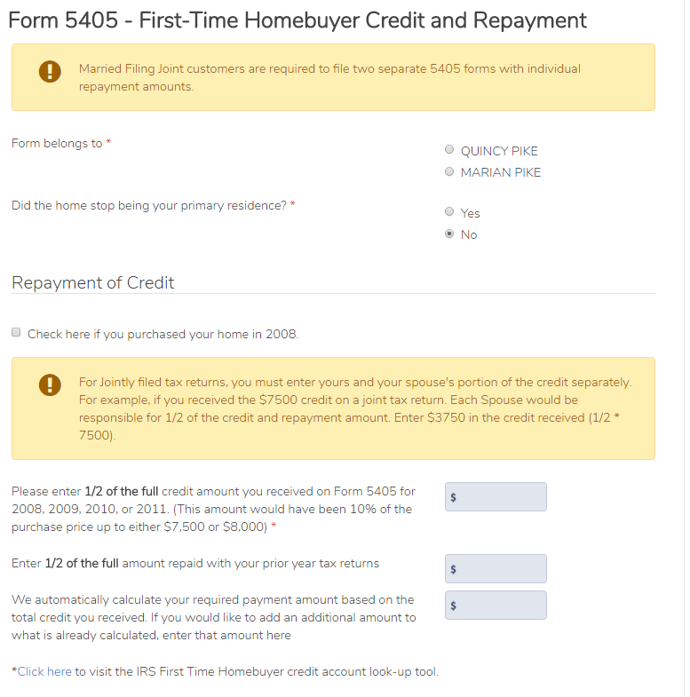
If not purchased in 2008, the return is out of scope
Enter applicable information
Select who the form is for. TP or SP
Note for MFJ returns
If the answer is “Yes” the return is OUT OF SCOPE

